**Example 1:**

#include <iostream>

#include <unistd.h>

#include <sys/types.h>

#include <sys/wait.h>

#include <csignal>

#include <cstring>

#include <cstdlib>

void handle_sigusr1(int sig) {

std::cout << "Received SIGUSR1 signal in process " << getpid() << std::endl;

}

void handle_sigusr2(int sig) {

std::cout << "Received SIGUSR2 signal in process " << getpid() << std::endl;

}

int main() {

signal(SIGUSR1, handle_sigusr1);

signal(SIGUSR2, handle_sigusr2);

int pipe_fd[2];

if (pipe(pipe_fd) == -1) {

std::cerr << "Pipe creation failed" << std::endl;

return 1;

}

pid_t pid = fork();

if (pid < 0) {

std::cerr << "Fork failed" << std::endl;

return 1;

} else if (pid == 0) {

close(pipe_fd[1]);

char buffer[128];

read(pipe_fd[0], buffer, sizeof(buffer));

std::cout << "Child process received: " << buffer << std::endl;

sleep(2);

kill(getppid(), SIGUSR1);

close(pipe_fd[0]);

} else {

close(pipe_fd[0]);

const char* message = "Hello from parent";

write(pipe_fd[1], message, strlen(message) + 1);

pause();

std::cout << "Parent process received signal from child" << std::endl;

wait(NULL);

close(pipe_fd[1]);

}

return 0;

}

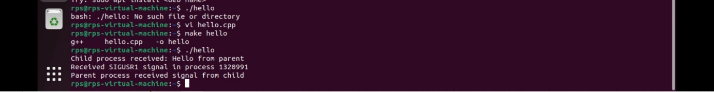

**Example 2:**

#include <stdio.h>

#include <stdlib.h>

int main() {

FILE *file;

int num, sum = 0;

// Open the file for reading

file = fopen("input.txt", "r");

if (file == NULL) {

printf("Could not open file input.txt\n");

return 1;

}

// Read integers from the file and calculate the sum

while (fscanf(file, "%d", &num) != EOF) {

sum += num;

}

// Close the file

fclose(file);

// Print the result

printf("The sum of the numbers in input.txt is %d\n", sum);

return 0;

}

**Example 3:**

#!/bin/bash

# Function to list all files in the directory

list_files() {

echo "Files in directory $1:"

ls -l "$1"

}

# Function to display the total number of files in the directory

count_files() {

count=$(ls -l "$1" | grep -v ^d | wc -l)

echo "Total number of files in directory $1: $count"

}

# Function to copy a specified file to a new location

copy_file() {

if [ ! -f "$1" ]; then

echo "Error: File $1 does not exist."

return

fi

cp "$1" "$2"

echo "File $1 copied to $2"

}

# Function to move a specified file to a new location

move_file() {

if [ ! -f "$1" ]; then

echo "Error: File $1 does not exist."

return

fi

mv "$1" "$2"

echo "File $1 moved to $2"

}

# Function to delete a specified file

delete_file() {

if [ ! -f "$1" ]; then

echo "Error: File $1 does not exist."

return

fi

rm "$1"

echo "File $1 deleted"

}

# Main script

if [ $# -lt 2 ]; then

echo "Usage: $0 <directory_path> <command> [file_path] [destination]"

echo "Commands:"

echo " list - List all files in the directory"

echo " count - Display the total number of files"

echo " copy <file> <dest>- Copy a file to a new location"

echo " move <file> <dest>- Move a file to a new location"

echo " delete <file> - Delete a specified file"

exit 1

fi

DIR_PATH="$1"

COMMAND="$2"

FILE_PATH="$3"

DEST_PATH="$4"

# Check if the provided directory is valid

if [ ! -d "$DIR_PATH" ]; then

echo "Error: $DIR_PATH is not a valid directory."

exit 1

fi

# Execute the corresponding function based on the command

case $COMMAND in

list)

list_files "$DIR_PATH"

;;

count)

count_files "$DIR_PATH"

;;

copy)

copy_file "$FILE_PATH" "$DEST_PATH"

;;

move)

move_file "$FILE_PATH" "$DEST_PATH"

;;

delete)

delete_file "$FILE_PATH"

;;

*)

echo "Invalid command. Use list, count, copy, move, or delete."

;;

Esac

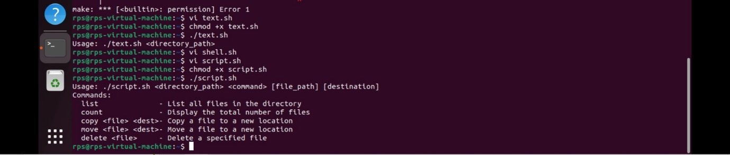

**Example 4:**

#!/bin/bash

# Check if the user provided a directory path as an argument

if [ -z "$1" ]; then

echo "Usage: $0 <directory_path>"

exit 1

fi

# Store the directory path

DIR_PATH="$1"

# Check if the provided argument is a valid directory

if [ ! -d "$DIR_PATH" ]; then

echo "Error: $DIR_PATH is not a valid directory."

exit 1

fi

# Change permissions of all files within the directory

find "$DIR_PATH" -type f -exec chmod 755 {} +

# Print a completion message

echo "Permissions changed to rwxr-xr-x for all files in $DIR_PATH."

**Example 5:**

#!/bin/bash

# Check if the user provided a directory path as an argument

if [ -z "$1" ]; then

echo "Usage: $0 <directory_path>"

exit 1

fi

# Store the directory path

DIR_PATH="$1"

# Check if the provided argument is a valid directory

if [ ! -d "$DIR_PATH" ]; then

echo "Error: $DIR_PATH is not a valid directory."

exit 1

fi

# Count the number of files in the directory

file_count=$(find "$DIR_PATH" -type f | wc -l)

# Count the number of directories in the directory

dir_count=$(find "$DIR_PATH" -type d | wc -l)

# Print the counts with appropriate labels

echo "Number of files in $DIR_PATH: $file_count"

echo "Number of directories in $DIR_PATH: $dir_count"

**Example 6:**

#!/bin/bash

# Check if the user provided the required arguments

if [ $# -ne 3 ]; then

echo "Usage: $0 <directory_path> <search_string> <replacement_string>"

exit 1

fi

# Store the arguments in variables

DIR_PATH="$1"

SEARCH_STRING="$2"

REPLACEMENT_STRING="$3"

# Check if the provided argument is a valid directory

if [ ! -d "$DIR_PATH" ]; then

echo "Error: $DIR_PATH is not a valid directory."

exit 1

fi

# Find and replace the search string with the replacement string in all files

find "$DIR_PATH" -type f -exec sed -i "s/$SEARCH_STRING/$REPLACEMENT_STRING/g" {} +

# Print a completion message

echo "Find and replace operation completed in all files within $DIR_PATH."

**Example 7:**

#!/bin/bash

# Check if the user provided a directory path as an argument

if [ -z "$1" ]; then

echo "Usage: $0 <directory_path>"

exit 1

fi

# Store the directory path

DIR_PATH="$1"

# Check if the provided argument is a valid directory

if [ ! -d "$DIR_PATH" ]; then

echo "Error: $DIR_PATH is not a valid directory."

exit 1

fi

# Generate a disk usage report for the directory

REPORT_FILE="disk_usage_report.txt"

du -sh "$DIR_PATH" > "$REPORT_FILE"

du -ah "$DIR_PATH" >> "$REPORT_FILE"

# Print a message indicating where the report is saved

echo "Disk usage report saved to $REPORT_FILE."

**Example 8:**

#include <iostream>

#include <fcntl.h>

#include <unistd.h>

#include <cstring>

int main() {

const char* filename = "example.txt";

const char* message = "Hello, World!";

char buffer[100];

// Create or truncate the file using open system call

int fd = open(filename, O_CREAT | O_WRONLY | O_TRUNC, S_IRUSR | S_IWUSR);

if (fd == -1) {

std::cerr << "Error: Failed to create or open the file." << std::endl;

return 1;

}

// Write the string to the file using write system call

ssize_t bytes_written = write(fd, message, strlen(message));

if (bytes_written == -1) {

std::cerr << "Error: Failed to write to the file." << std::endl;

close(fd);

return 1;

}

// Ensure that all bytes are written

if (bytes_written != strlen(message)) {

std::cerr << "Error: Not all bytes were written to the file." << std::endl;

close(fd);

return 1;

}

// Reset the file pointer to the beginning using lseek system call

if (lseek(fd, 0, SEEK_SET) == -1) {

std::cerr << "Error: Failed to reset the file pointer." << std::endl;

close(fd);

return 1;

}

// Read the contents of the file using read system call

ssize_t bytes_read = read(fd, buffer, sizeof(buffer) - 1);

if (bytes_read == -1) {

std::cerr << "Error: Failed to read from the file." << std::endl;

close(fd);

return 1;

}

// Null-terminate the buffer and print the contents

buffer[bytes_read] = '\0';

std::cout << "File contents: " << buffer << std::endl;

// Close the file descriptor using close system call

if (close(fd) == -1) {

std::cerr << "Error: Failed to close the file." << std::endl;

return 1;

}

// Delete the file using unlink system call

if (unlink(filename) == -1) {

std::cerr << "Error: Failed to delete the file." << std::endl;

return 1;

}

std::cout << "File operations completed successfully." << std::endl;

return 0;

}